13. Check that you have generated the Customercontroller class and run the new customer manager

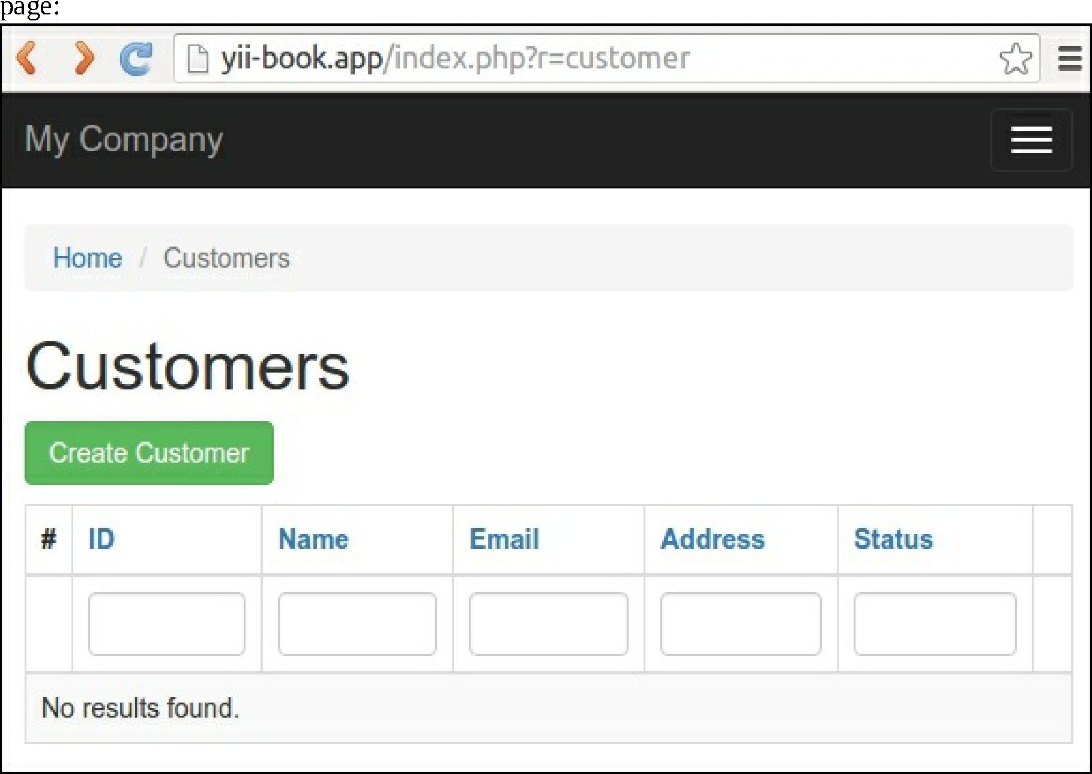

14. You may create, update, and delete your customers’ data right now.

15. Look for the Debug panel in the page footer:



16. You can see the total MongoDB query count and total execution time. Click on the count badge and inspect the queries: